Dear Parents and children of Beech and Maple class,
As the weather has increased in heat, we are giving you some home learning to do. This will be split into three parts for each day. Please feel free to record these on paper or whiteboards.
English: The Explorer
As a year group, we have been reading chapters from the book the Explorer by Katherine Rundell. Your first challenge is to write a diary entry imagining you are Con or one of the other main characters.
You should include
I have included
Capital Letters, Full stops, punctuation
First person
Past tense
Fronted adverbials

An example might look like this.
Dear Diary,
It has been days since our plane crashed and I still don’t think we will be saved. After the crash, all I have eaten is crushed up bug pancakes. Before long, I am going to crazy with only the few friends I have.
Maths:
During our maths topics we have been exploring statistics.
Firstly you will need to complete this link on BBC bite size. There are several questions which you can answer and you will find out if you are right.
https://www.bbc.co.uk/bitesize/topics/z7rcwmn/articles/z4dgvwx
After you have looked at this, please login to TTRS where we have set up a battle for you to take part in across the two days.
Topic: Rainforest
Research a rainforest and use your knowledge of geography to create a fact file on that specific rainforest. You can create a page or even a double page spread. It might look something like this.
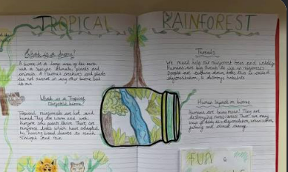
Dear Parents and children of Beech and Maple class,
As the weather has increased in heat, we are giving you some home learning to do. This will be split into three parts for each day. Please feel free to record these on paper or whiteboards.
English: The Explorer
As a year group, we have been reading chapters from the book the Explorer by Katherine Rundell.
Listen to this chapter, https://www.youtube.com/watch?v=YLwheE6B6dM
This is the chapter the maiden voyage. Your challenge is to write a chapter summary of the chapter in less than 100 words.
For example
In the first chapter, the book begins with a group of children on the runway, getting ready to go on a flight across the amazon.

Maths:
During our maths topics we have been exploring statistics.
Firstly you will need to complete this link on BBC bite size. There are several questions which you can answer and you will find out if you are right.
https://www.bbc.co.uk/bitesize/topics/z7rcwmn/articles/z4dgvwx
After you have looked at this, please login to TTRS where we have set up a battle for you to take part in across the two days.
Topic: Rainforest
Today, you are going to create a piece of found art based on the rainforest. You could use recycling or paper. You could use leaves and flowers you find in your garden. Try to make a rainforest scene of take a picture of it.
